Terry Jacobsen

Educational Consultant

Raue Center for the Arts

26 N. Williams Street

Crystal Lake, IL 60014

To Whom It May Concern, May 20, 2021,

On behalf of the Raue Center for the Arts, I’m Terry Jacobsen, educational consultant. The Raue Center for the Arts is a 501(c)3 non-profit organization dedicated to enriching the lives of all through the arts. Located in downtown Crystal Lake, the Raue is not only a McHenry County gem, but also a revered theatre for the greater Chicagoland area.

The Raue Center for the Arts is about to celebrate 20 years!! Over those 20 years, Raue has:

* welcomed over 1 million audience members
* provided arts in education for 350k students from 36 different towns
* cultivated local talent with Sage Studio and WSREP training programs
* championed diversity and local talent
* continued to instill pride as an economic incubator with a direct tax impact of 4.3 million (according to the IAC: Illinois Arts Council and the Governor's Office)
* received multiple grants and awards from the NEA, IAC, GOVERNORS office and many more

Opportunities for students to see live theatre continues to be a strength and priority of the Raue Center. For years students from around the county and beyond have viewed and participated in shows offered through Mission Imagination.

The Raue is proud to be able to offer Mission Imagination shows once again for students during the 21-22 school year! With a wide variety of choices, there’s sure to be a show for every age group and grade level.

We look forward to providing the best opportunities within a live theatre setting for all students. Please circulate the information included to appropriate personnel so that plans may be set in motion for students to visit the Raue Center and see a show!

Sincerely,

Terry Jacobsen

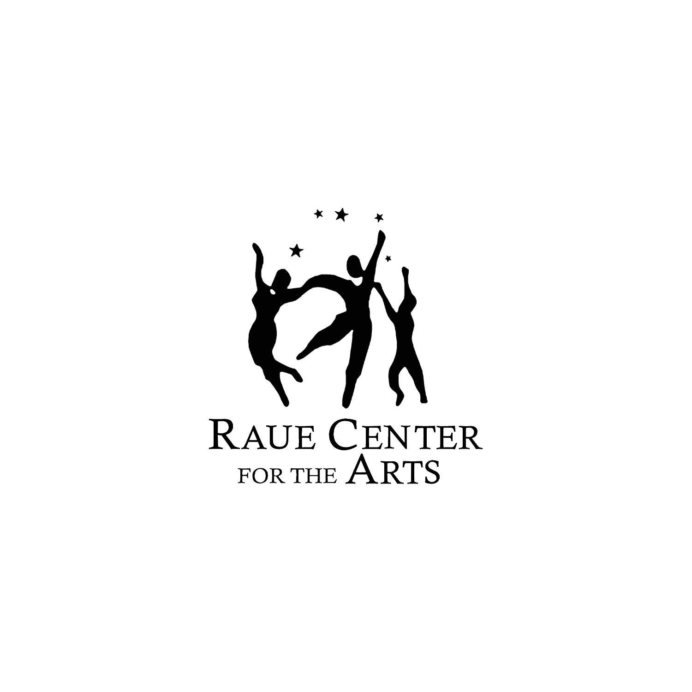

Tim Paul,

*president*

John Jacobsen,

*vice president*

William Schmiel,

*secretary*

Chuck Stevens,

*treasurer*

Luanne Flavin

Chris Gray

John Green

Michael Johnson

Richard Kuranda

Stacey McInerney

Jack Minsley

Rich Naponelli

Michelle Nowland

Sandra Pierce

Ravelle Scherer

Steven Szalaj

Raue Center For The Arts is a 501(c)3 nonprofit organization dedicated to enriching the lives of all through the arts.